**VAIBHAV BALDEVA**

**102203568**

**2CO29**

**Q1) Introduction of internal and external commands.**

Ans) **Internal Commands:**

Internal commands, also referred to as built-in commands, are those commands that are directly embedded within the shell or command interpreter. They are an integral part of the operating system's command processor and do not exist as separate executable files on the disk. When you enter an internal command, the shell itself handles its execution without needing to call an external program. Common examples of internal commands include commands for changing the current directory (cd), displaying the contents of a directory (dir or ls), clearing the screen (clear or cls), displaying the system date and time (date or time), and managing environment variables (set). Advantages of internal commands include their faster execution speed and seamless integration with the shell's functionality. However, they might have limited capabilities compared to external commands.

**External Commands:**

External commands are standalone programs or executable files that are separate from the shell. These commands are stored as individual files on the disk, and when invoked, the shell locates and runs the corresponding executable file to perform the requested action. External commands are capable of performing a wide range of tasks, from manipulating files and directories to executing complex operations like compiling code or interacting with network services. Examples of external commands include compilers (e.g., gcc), text editors (e.g., nano, vim), system management tools (e.g., chkdsk or fsck), and network-related utilities (e.g., ping or wget). External commands offer greater functionality and flexibility but might take slightly longer to execute due to the overhead of launching a separate program. In summary, internal commands are built into the shell itself and are executed by the shell's interpreter, while external commands are separate executable files that are run by the shell. Both internal and external commands play crucial roles in enabling users to interact with and manage computer systems efficiently. Understanding the distinction between these types of commands is essential for effectively navigating and utilizing command-line interfaces.

**Q2) Feeding output of one command to another command by pipelining.**

Ans) Pipelining is a powerful feature in Linux that allows you to combine two or more commands, take the output of one command and use it as the input to another command. This allows you to create complex and efficient command sequences by chaining together multiple commands. The pipe symbol | is used to implement pipelining in the command-line interface. Linux pipe are used for communication between applications, between Linux commands, and between applications and commands. This direct connection between commands/ programs/ processes allows them to operate simultaneously and permits data to be transferred between them continuously rather than having to pass it through temporary text files or through the display screen. Pipes are unidirectional i.e., data flows from left to right through the pipeline.

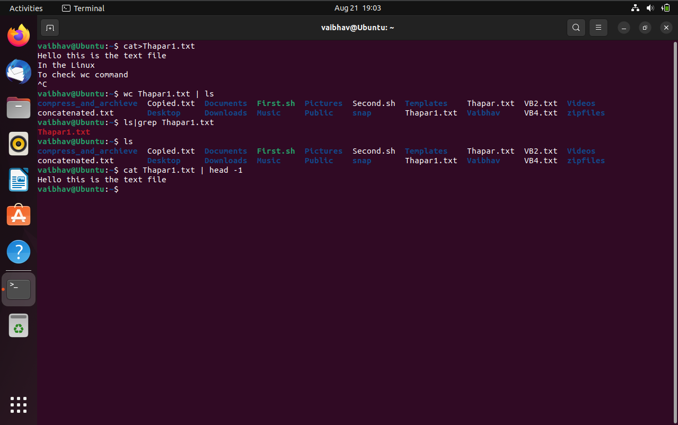

**Q3) expr, locating command.**

Ans) **expr command:-**

The expr command in Unix evaluates a given expression and displays its corresponding output. It is used for basic operations like addition, subtraction, multiplication, division, and modulus on integers. Also, Evaluating regular expressions, string operations like substring, length of strings etc.

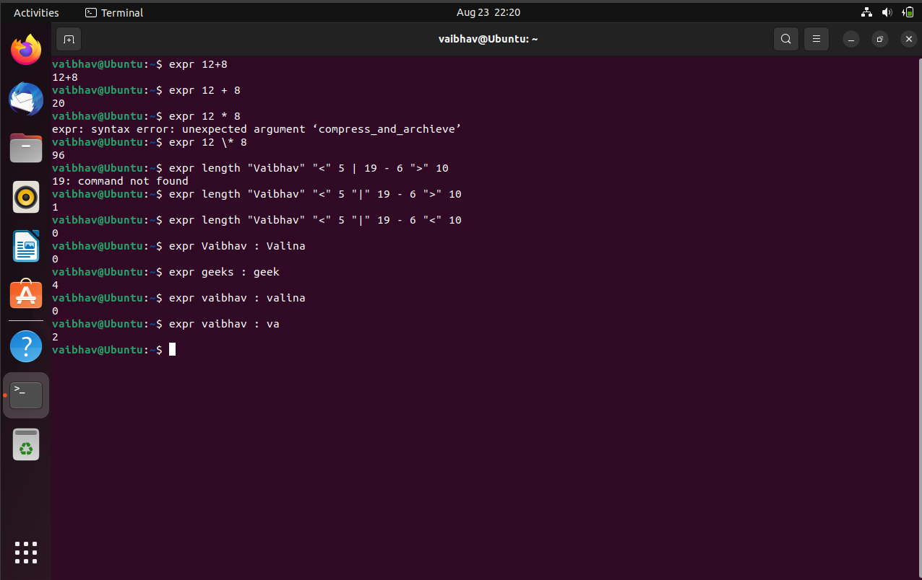

**Q4) echo command.**

Ans) The echo command is a fundamental command-line utility in Unix-like operating systems, including Linux. It is used to display text or output to the terminal. When you execute the echo command followed by a string of text, the command simply prints that text to the terminal .

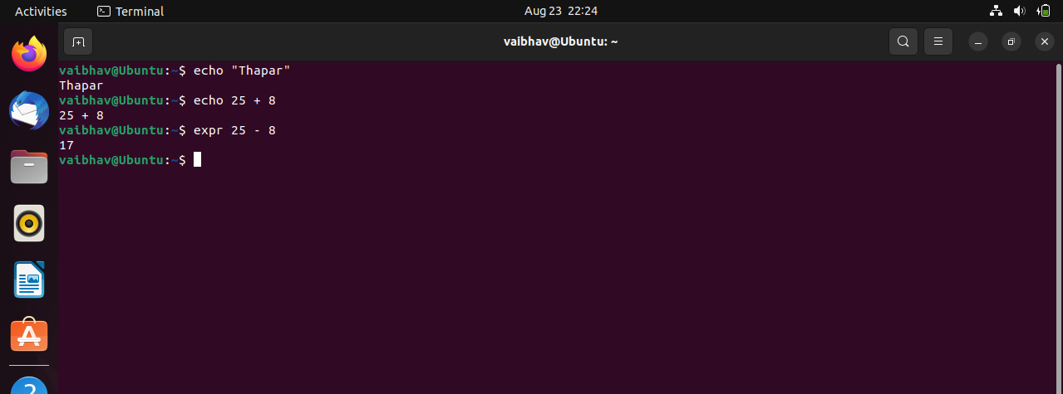

**Q5) Using . and ..**

Ans) . In the context of Unix-like operating systems, . and .. are special directory entries that have specific meanings: . (dot): This represents the current directory you're in. It's a reference to the directory you're currently working within. .. (dot-dot): This represents the parent directory of the current directory. It's a way to reference the directory one level up in the hierarchy. You can use these special directory entries in various ways, including in command-line operations and scripts.

For example, if you're in a directory and you want to list the contents of the parent directory, you can use the ls command with ..:

**ls ..**If you want to copy a file from the parent directory into the current directory, you could use the cp command like this: **cp ../file.txt** .In this example, ../file.txt references a file one level up, and the . at the end specifies the current directory as the destination.

In summary, . represents the current directory, and .. represents the parent directory. These special entries are handy when navigating and working with directory structures from the command line or within scripts.

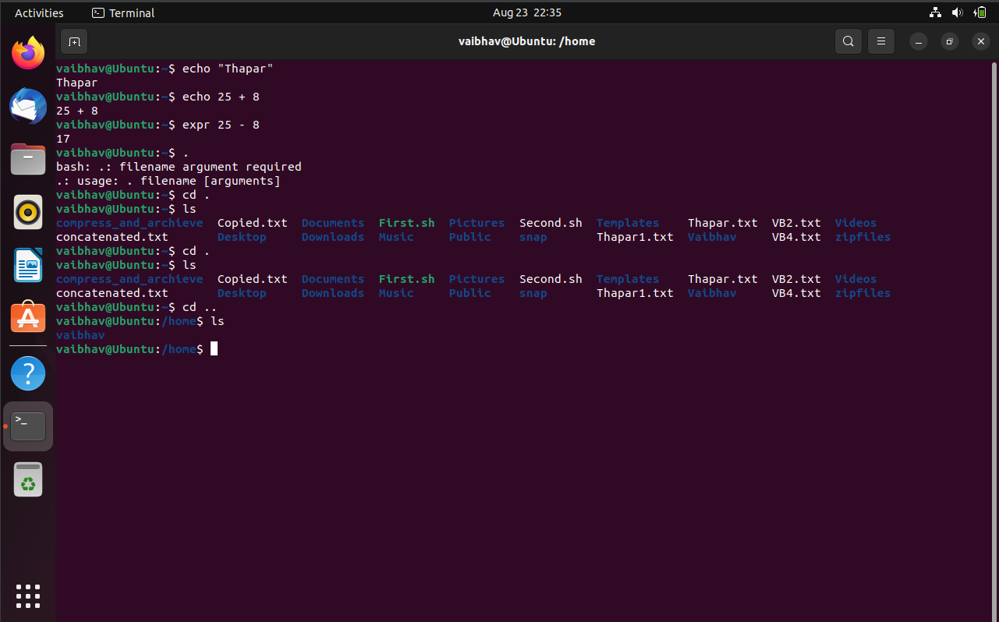

Q6) Ways for signing off from linux.

Ans) Signing off or logging out from a Linux system can be done using various methods, depending on the interface you are using and your access privileges. Here are some common ways to sign off from a Linux system:-

* Using the Terminal:
  + Logout Command: Open a terminal window and simply type the logout command, then press Enter. This will log you out of the current terminal session.
  + Ctrl + D: In most terminal emulators, you can also press Ctrl + D to signal the end of input, which will effectively log you out if no other processes are running in the terminal.
* Using SSH: If you are connected to the Linux system remotely using SSH:
* Exit Command: In the SSH session, you can type exit and press Enter to close the SSH connection and log out.
* Graphical User Interface (GUI): If you're using a graphical desktop environment like GNOME, KDE, or XFCE:
* Logout Option: Click on the "Power" or "User" icon in the top-right or bottom-right corner of the screen. You should see an option to "Log Out" or "Sign Out." Selecting this option will log you out of the current user session.
* Ctrl + Alt + Delete: Pressing Ctrl + Alt + Delete might bring up a menu that allows you to log out or restart the system, depending on the configuration of your desktop environment.
* Shutdown Dialog:
  + Shutdown/Restart Dialog: Similar to logging out, the shutdown or restart dialog often provides an option to log out before shutting down or restarting the system. You can access this dialog through the desktop environment's power options.
* Using TTY: If you're using a virtual terminal (TTY) without a graphical environment:
* Exit Command: In a TTY session, you can use the exit command to log out and return to the login prompt.
* It's important to note that the specific steps might vary slightly based on the Linux distribution and the desktop environment you are using. Always ensure that you've saved any unsaved work before logging out to avoid data loss.

**Q7) Ping, Man and help command.**

Ans)

* Man command : man command in Linux is used to display the user manual of any command that we can run on the terminal. It provides a detailed view of the command which includes NAME, SYNOPSIS, DESCRIPTION, OPTIONS, EXIT STATUS, RETURN VALUES, ERRORS, FILES, VERSIONS, EXAMPLES, AUTHORS and SEE ALSO.

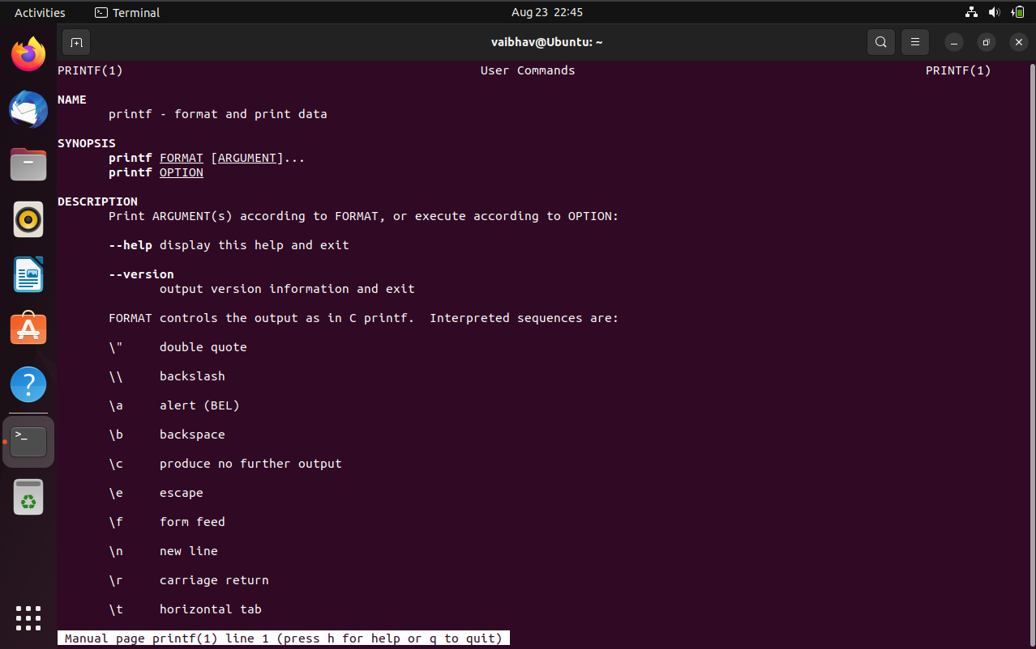

* Help command : In computing, help is a command in various command line shells such as COMMAND.COM , cmd.exe , Bash, qshell, 4DOS/4NT, Windows PowerShell, Singularity shell, Python, MATLAB and GNU Octave. It provides online information about available commands and the shell environment.

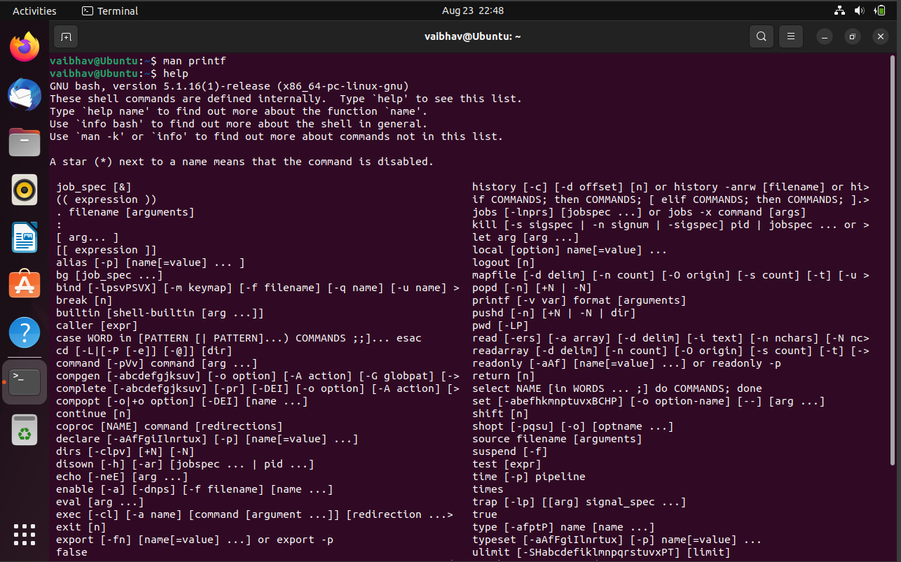

* Ping command : ping is the primary TCP/IP command used to troubleshoot connectivity, reachability, and name resolution. Used without parameters, this command displays Help content. You can also use this command to test both the computer name and the IP address of the computer.
  + Ping -c 3(for three times only)
  + Ping -I 2(interval to send packets)
  + Ping –c 5 –q(this will only give you summary)
  + Ping –f(to send packets as fast as possible to test the network performance)
  + ping –s 500(change size of packet)
  + ping –w 10(to stop printing after 10 second)
  + ping –a(audible)

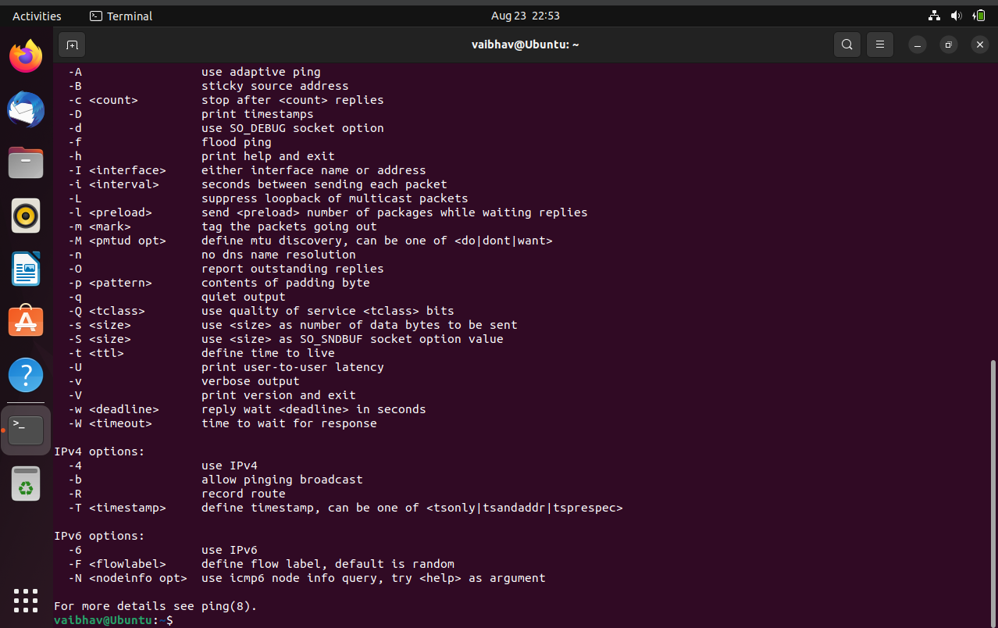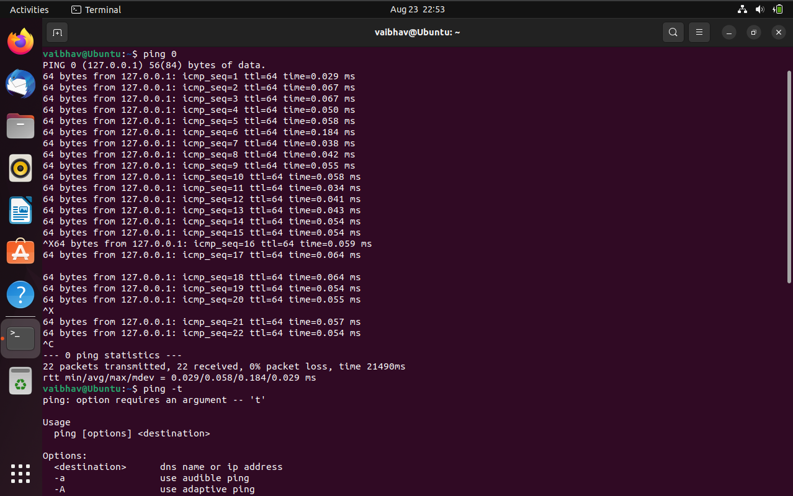

**Q8) Combining the commands.**

Ans)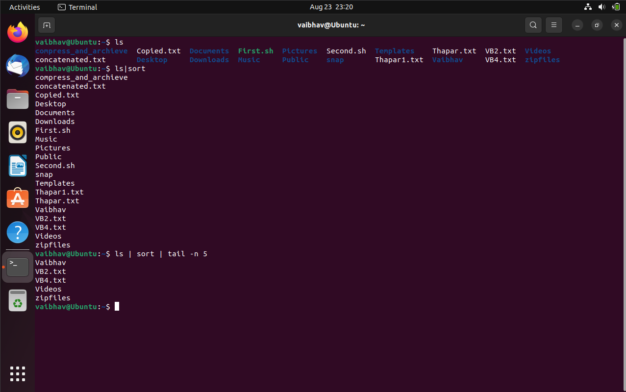

**Q9) File permissions and changing the access rights (chmod).**

Ans) 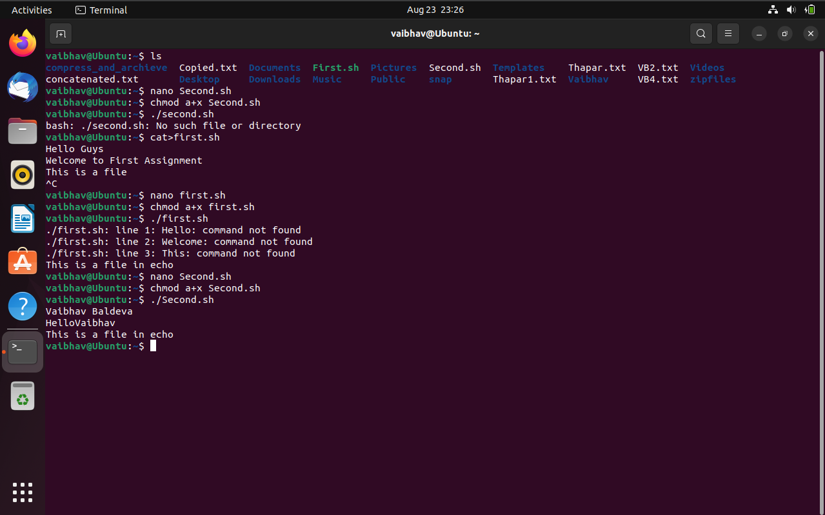

**Q10)vi editor and its basics: write a small paragraph using vi editor.**

Ans) The default editor that comes with the UNIX operating system is called vi (visual editor). Using vi editor, we can edit an existing file or create a new file from scratch. we can also use this editor to just read a text file. The advanced version of the vi editor is the vim editor. When vi starts up, it is in Command Mode. This mode is where vi interprets any characters we type as commands and thus does not display them in the window. This mode allows us to move through a file, and delete, copy, or paste a piece of text. Enter into Command Mode from any other mode, requires pressing the [Esc] key. If we press [Esc] when we are already in Command Mode, then vi will beep or flash the screen. vi is generally considered the de facto standard in Unix editors because −

• It's usually available on all the flavors of Unix system.

• Its implementations are very similar across the board.

• It requires very few resources.

• It is more user-friendly than other editors such as the ed or the ex.

